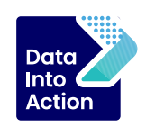

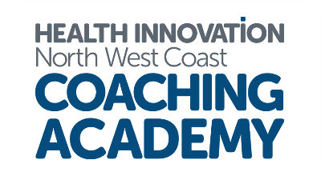

NHS Cheshire and Merseyside
Population Health Academy Programme
What: an interactive learning programme with training on tools and dashboards alongside active learning discussions and coaching approaches
Why: to create consistency across the ICS around data-informed decision making and to strengthen and empower leaders in our system around the use of data to address health inequalities
Who: for anyone responsible for commissioning or transforming services in each Place across C&M ICS
When: Cohort one running June – August 2024
Where: Microsoft Teams and FutureNHS
Participants will attend three virtual workshops, each focussed on readily available tools and dashboards that support data informed decision making:
- Enhanced Case Finding Tool
- Waiting List Dashboard
- Complex Households
In addition, we will cover the Business Intelligence Portal and Real-World Intervention Causal Evaluation (RICE) methodology across the duration of the programme.
Participants will also attend three virtual active learning sets based on real-life data-focussed case studies around a selection of defined topics.
The programme is CPD accredited, and participants must be able to attend all dates.

Programme Design
Workshops and active learning sets will be delivered virtually via Microsoft Teams with additional digital collaboration on our dedicated FutureNHS workspace. Subject matter experts will join the workshops and the active learning sets to share their expert knowledge around the tools in focus and their application in the business setting as well as sharing relevant case studies. In addition, there will be time to reflect on the application of these tools and dashboards in your own workplace and the culture and behaviours required for success.
Workshop 1: Enhanced Case Finding Tool (ECFT)
5th June 9:30 – 12:00
Subject matter experts will lead a session on the functionality of the ECFT and offer support on how to use the tool to the best effect.
Active Learning Set 1: Case study one – topic TBC
19th June 09:30 – 11:30
Workshop 2: Waiting List Dashboard
25th June 09:30 – 12:00
This tool enables the review of waiting lists across the ICS and the ability to delve into the characteristics and needs of those waiting to receive care.
Active Learning Set 2: Case study two – topic TBC
11th July 09:30 – 11:30
Workshop 3: Complex Households
Date TBC – once the cohort is confirmed we will schedule this date
Working through the insight and associated opportunities for families with multiple complexities, often associated with poverty and broader determinant challenges we will use the tool to identify cross sector solutions.
Active Learning Set 3: Case study three – topic TBC
Date TBC - once the cohort is confirmed we will schedule this date
One to one coaching:
All participants will also have the option to attend 3 x 45-minute individual coaching sessions across the duration of the programme with a qualified coach to address any individual needs.
To receive more information, please email
Natalie.Latham@healthinnovationnwc.nhs.uk

