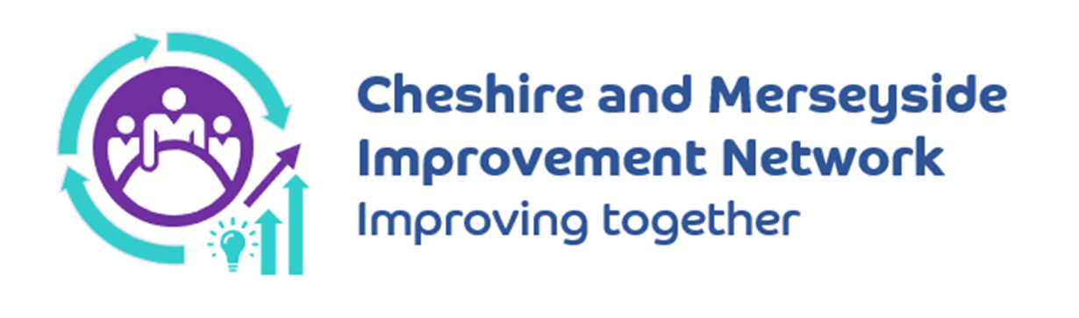

In Nov 2023, the Cheshire and Merseyside Improvement Network (CaMIN) met for the first time. Made up of improvement colleagues from the 17 providers across Cheshire and Merseyside our initial focus has been on understanding what each provider is doing in relation to NHS Impact and we have met monthly since, rotating the meetings across the different provider sites.

We generally meet for a morning or an afternoon and we are now supported electronically by a Teams channel which is growing. The Network has been positively received and is supported by the ICB. The meetings are informal and provide opportunities for sharing, learning and collaborating across our patch. We strive to be data led, develop connectivity and collaboration across the system whilst also being person centred and supportive of development of leadership and continuous improvement capacity.

We are not an exclusive network and we recognise that we don’t have representation from primary care, our local authorities and other community providers but would very much welcome colleagues from these areas along to join us. We want the network to grow and flourish and be an important element of continuous improvement across Cheshire and Merseyside so please help us in this aim.

If you are interested in joining the network or in finding out more then please contact Natalia Armes ([natalia.armes@cheshireandmerseyside.nhs.uk](mailto:natalia.armes@cheshireandmerseyside.nhs.uk)) , Liam Doyle ([Liam.Doyle@liverpoolft.nhs.uk](mailto:Liam.Doyle@liverpoolft.nhs.uk)), Jennie Williams ([Jennie.Williams@alderhey.nhs.uk](mailto:Jennie.Williams@alderhey.nhs.uk)) or Helen Walker ([hwalker8@nhs.net](mailto:hwalker8@nhs.net)).

To access the Microsoft Teams channel please follow the QR Code below:

