Making Toothbrushing Fun!

Try to make toothbrushing fun, by playing songs, using apps or timers whilst toothbrushing is taking place:

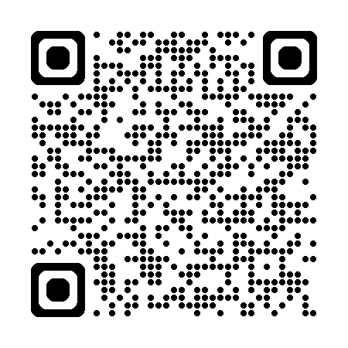
Hey Duggee - Toothbrushing Song
Join Duggee and the Squirrels for 2 minutes of toothbrushing with this catchy song but remember not to wet the toothbrush before applying toothpaste.
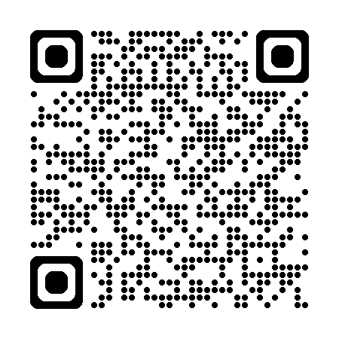

Sesame Street – Healthy teeth, Healthy me
Join Elmo and his friends and get brushy brush brushing.

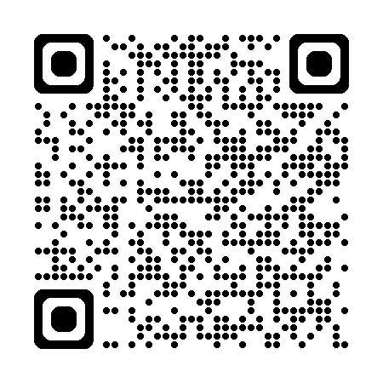
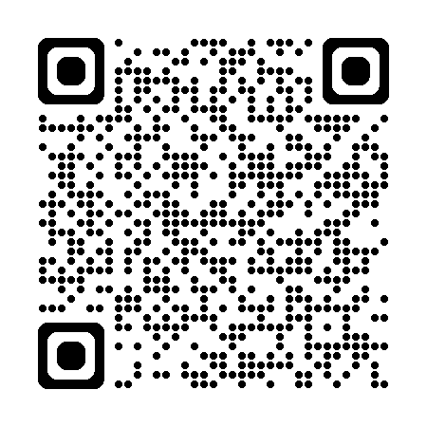
Finny The Shark – Brush Your Teeth
Finny and friends are brushing their teeth and staying clean and healthy.
Super Simple Songs - Brush Your Teeth
Sing along with 3 smiley monsters who brush morning and night.

