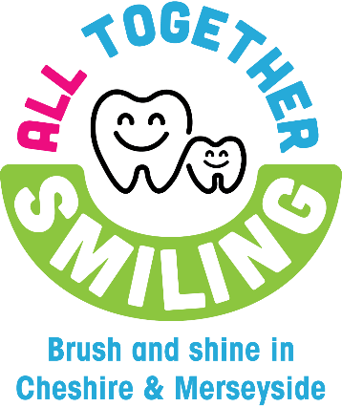




When your chart is complete, return it to your nursery
or school to receive your Toothbrushing Certificate!
 Tick each box when you have brushed your teeth at home.
Brush your teeth at home twice a day. Once before bed and one other time,
as well as brushing at nursery or school.
Don’t forget to keep going!
Home Toothbrushing Chart
Get into the toothbrushing habit!
Monday
Friday
Sunday
Wednesday
Thursday
Saturday
Tuesday

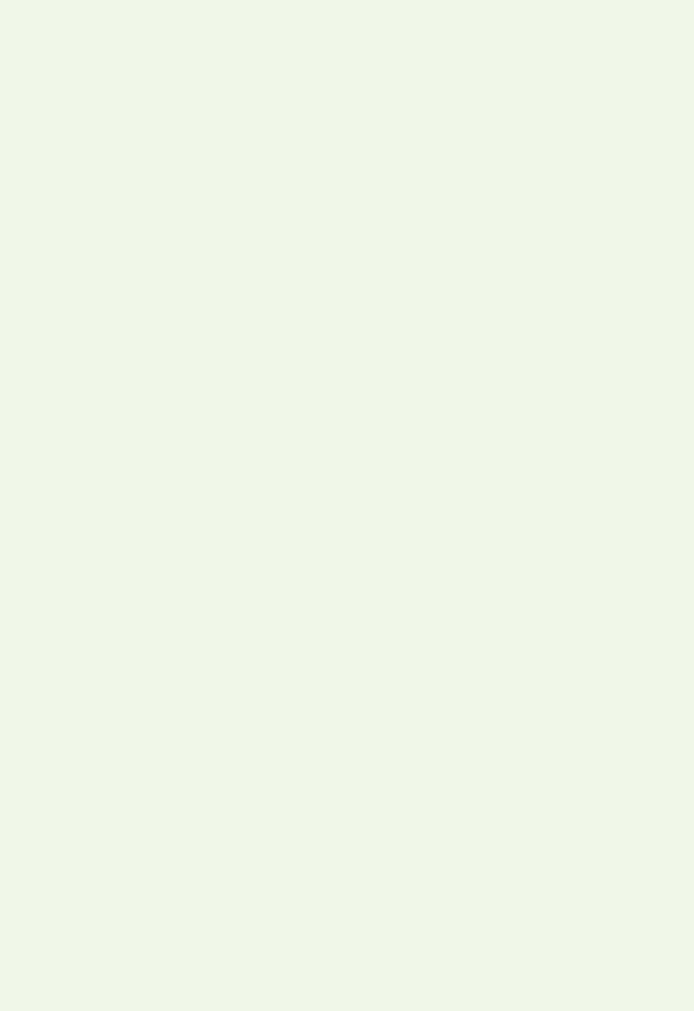









Toothbrush ng
Certificate

Well done!
This is to certify that _______________ is into the toothbrushing habit and is brushing their teeth twice a day to keep them sparkly and white!

